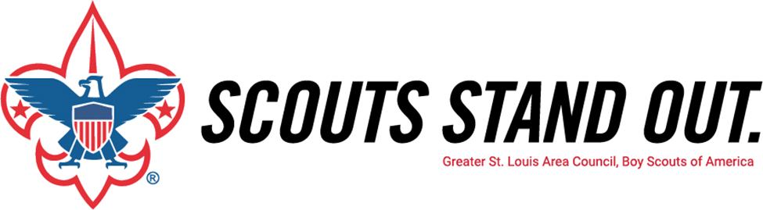
Greater St. Louis Area Council, Boy Scouts of America
{DATE - TWO WEEKS AHEAD OF PRESENTATION}

Dear {PARENTS FIRST NAME(S)},

On {PRESENTATION DATE}, our Scout {PACK/TROOP/CREW/POST}Troop will have a presentation at our {BLUE&GOLD/COURTOFHONOR/PARENTMEETING}Court of Honor regarding the Greater St. Louis Area Council’s Family Friends of Scouting campaign. Friends of Scouting is our Council’s annual giving campaign. Our {PACK/TROOP/CREW/POST}Troop goal for the 2020 campaign is ${UNIT GOAL} and I am counting on YOU to help us achieve 100% participation in the campaign.

What you may not know is the cost to provide our quality programs per Scout is $204, which provides one year of the wonderful program for each Scout beyond your BSA registration fees – which go directly to the National BSA Office.

Our annual Friends of Scouting campaign provides the direct support for our {PACK/TROOP/CREW/POST}Troop Troopand its leaders by providing:
• Camp properties for summer and weekend  camping and activities  • Activities and Programs for your Scouts  • Training and Courses for leaders  • Assistance to disadvantaged youth | • Program outreach  • Membership recruitment and Advancement  • Service Centers and Scout Shops  • Accident and General Liability Insurance
As a Scout parent, we see first-hand the benefits of Scouting and we hope you will consider giving a voluntary contribution to the campaign for 2020.

Every gift is important to the success of our Scouting programs. There are opportunities for everyone to support the Family Friends of Scouting at a level that can help us along, propel us forward, or even leave a legacy. There are many ways to give to the Family Friends of Scouting Campaign through:
- a cash or check donation at the presentation
- Text {REGIONAL KEYWORD} to 91999 to donate today via credit or debit card ***new this year***
- or through a pledge that is paid on a monthly, quarterly, or semiannual basis

At our upcoming {BLUE&GOLD/COURTOFHONOR/PARENTMEETING}Court of Honor Court of HonorCourt of Honorwe will be asking Scout parents, such as ourselves, to contribute what we can to help maintain and grow the quality program Scouting offers to the youth of our {PACK/TROOP/CREW/POST}. I, myself, will be making a kickoff gift to help us make our goal and I hope you will join me.

Yours in Scouting,

{UNIT COORDINATOR NAME}
{PACK/TROOP/CREW/POST} {UNIT NUMBER} FOS Coordinator

Watch the campaign video here:
https://youtu.be/CyvtU8klKn8

