Cub Scout Religious Emblem Program

(Insert Date)

All Scouts & Parents
(Insert Pack)
(Insert City & State)

Greetings,

By virtue of the twelve points of the Scout Law a Scout is Reverent. He or she is reverent toward God. He or she is faithful in his religious duties and respects the convictions of others in matters of custom and religion. As your Cub Scout Packmaster it is my duty to encourage our Scouts to pursue the religious emblem square knot by completing the Scouting and faith program for their denomination.

Here are the religious emblem square knot and medals for general Christian denominations:

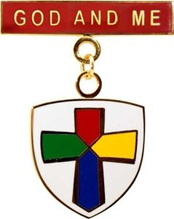 | 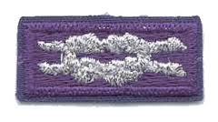 | 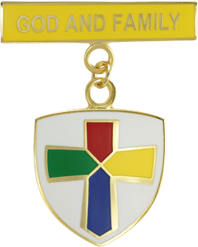
God and Me is meant for early elementary aged Scouts. God and Family is meant for late elementary aged Scouts. Upon successful completion you will be awarded both a square knot and a medal. Additionally, the Jesus and Me program is available to kindergarten aged Scouts and a lapel pin is awarded.

If you are interested in working on your religious emblem please discuss this with your minister or religious leader early this fall. I will order counselor and scout books that will direct the study and the requirements must be completed. Once your religious leader agrees to be a counselor and take you on as a student for this religious emblem please return the attached and signed agreement. At that time, I will give you the materials to start your study. In closing, the goal is to have this complete by the second week of January, so you can be awarded your religious emblem square knot and medal on Scout Sunday in February.

Be well, do good work, and keep in touch… may peace be with you.

Yours in Scouting,

(Insert Name),
Packmaster

Cub Scout Religious Emblem Agreement

Name of Scout:
Phone Number of Scout:
Name of Church:
Phone Number of Church:
Name of Pastor:
Email of Pastor:
Emblem To Work On: | Jesus and Me (Kindergarten)  God and Me (Early ELM) or God and Family (Late ELM)
Target to Complete: | Second Week of January

We agree to use the curriculum, activities, and general timeline in counselor manual and the student workbooks. We agree to spread this study of faith over the next three months and to have the work completed by the second weekend of January.

Upon successful completion of the program the counselor agrees complete the award application form at the end of the student workbook. The church where the Scout completes the religious award is responsible for the purchase of the medallion and will reimburse Pack. Our Pack is responsible for purchase of the religious emblem square knot and workbooks for counselor and student. The Pack will make one order of workbooks in early fall and one order of awards in early winter from P.R.A.Y.

We agree to notify the Scoutmaster by the second week of January or earlier about completion of the religious emblem program so plans for award ceremony can be made for Scout Sunday in February. Award Applications, Medal and Square Knot Orders, and Checks will be forwarded to the Packmaster so one order for the Pack can be made in January.

Official Signatures & Date:

Scout Signature & Date
Parent Signature & Date
Pastor Signature & Date

