2017 BT WINTER KLONDIKE - Cold Weather Camping Presentation, PPT Slides and Notes
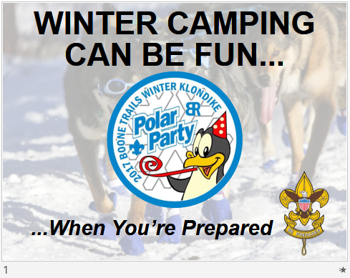 | - Winter Camping CAN be FUN (and SAFE) when you’re prepared.  - In this case, Being Prepared means having some general knowledge on how:  - The human body regulates temperature and loses heat;  - You can help it by dressing properly to mitigate heat loss;  - To keep it fueled up through hydration and fuel-heavy hot meals; and,  - To recognize, prevent and treat common cold weather injuries.  - When you’re prepared, prepare to have FUN in this unique environment.
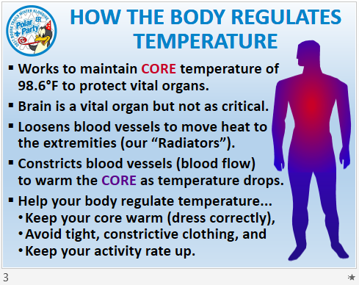 | - With severe hypothermia, the body reduces blood flow to the brain to maintain CORE heat. If the body fails, CLINICAL death (heart, lungs, and other vital organs) will precede BRAIN death.  - Blood supply to the heart & lungs is the highest priority (THEY supply oxygenated blood!) - that is what’s meant by the “brain is not AS critical.”  - “Old School Wisdom” - people that complained about having cold feet were told to “put on a hat” (i.e. - stop losing so much heat through the head and the body can then spare some for your feet).
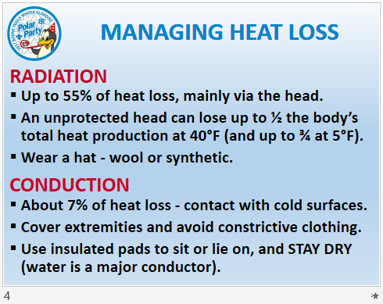 | - The 5 “shuns” (-tions)... the body loses heat in five (5) ways:  - Radiation  - Conduction  - Convection  - Evaporation  - Respiration
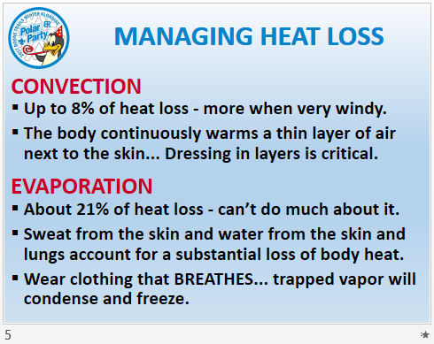 | - So, while you can’t stop evaporation, you can reduce it by not over-exerting and overheating.  - Clothing that breathes prevents ice build-up which helps keeps you warmer.
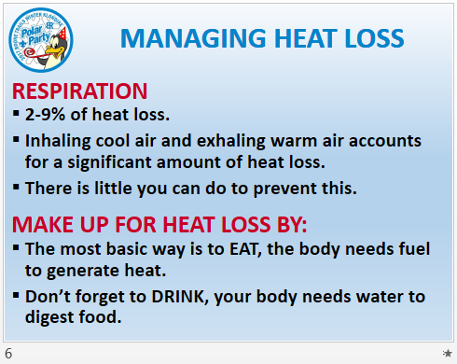 | - A Balaclava is a hood with a nose piece than can help you “pre-warm” air a little before inhaling it.  - When your campfire starts to burn low, what do you do?  - Fueling your body with food is just like throwing some more wood on a fire.
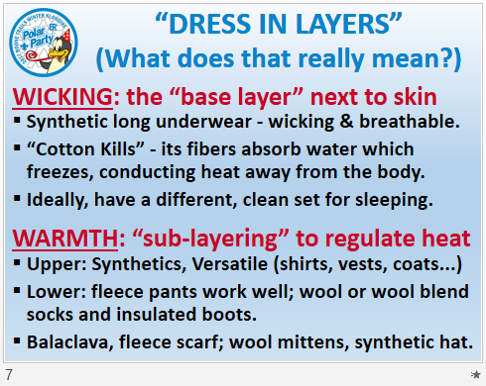 | - There are 3 classifications of layers:  - Wicking,  - Warmth and  - Wind & Water  - I’ve added Water as the two combined can be deadly
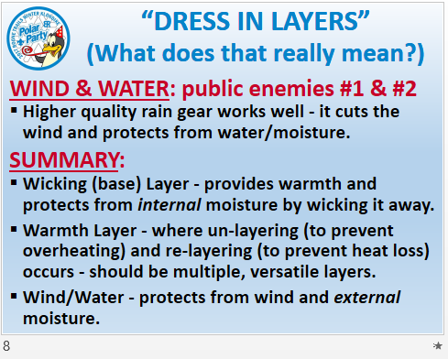 | - A Balaclava is a hood with a nose piece than can help you “pre-warm” air a little before inhaling it.
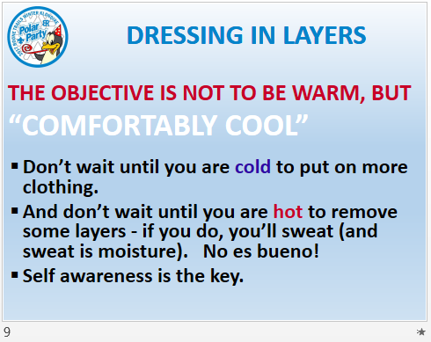 | - “Comfortably Cool” is the key - it’s the “center-point” between being Cold and being Overheated.  - And the center-point is where you achieve balance.
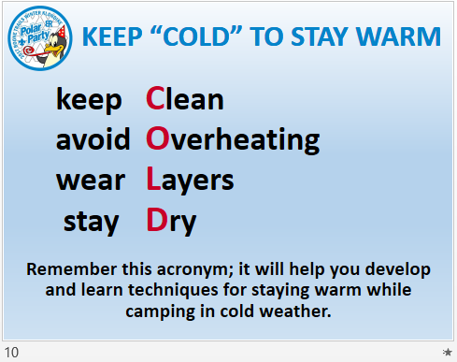 | - CLEAN: while it refers to your clothes since dirt clogs up the spaces in the weave of the cloth and reduces its effectiveness...  - It also refers to your body which produces some of the gunk that clogs up the weave.  - Wet Ones AND A TOWEL are one way to take a “dry bath.”
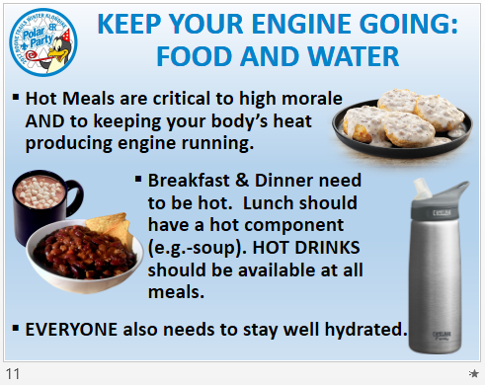 | - The analogy earlier about throwing more logs on a dying fire is right on target...  - Heat Loss WILL happen, no matter how much we try to minimize it.  - The key is to produce more than you lose - to stay ahead of the game.
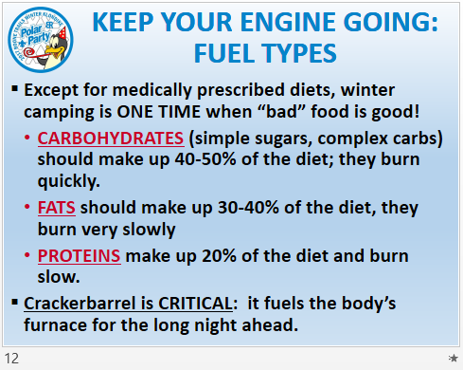 | - Crackerbarrel also provides time for fellowship and to observe each other, to see who might be under a bit more stress than the others.  - It’s a time to take stock of one another - and yourself... the night can be long.
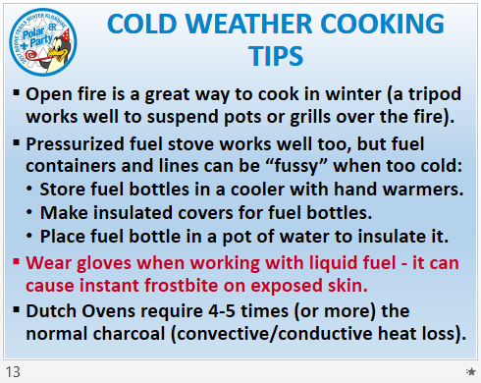 | - Using some reasoning and common sense, then experimenting with options helps YOU find what works best for YOU. The challenge is part of the experience... but when you find a solution, you OWN that solution.  - An Okpik patrol discovered this method.  - USE RUBBER GLOVES!
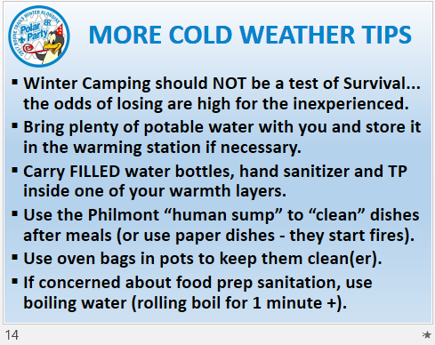 | - I can’t emphasis this enough... a “SURVIVAL” mentality can lead to take chances and making foolish choices.  - In freezing temperatures, food “bugs” aren’t a major problem. Not like they are in the middle of July at The Ranch.
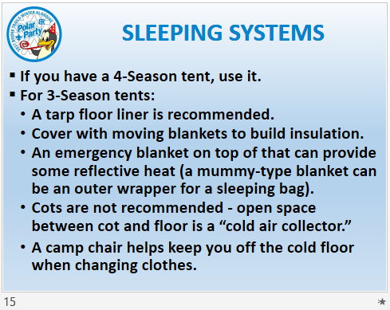 | - All tents hold some warmth and protect from the wind to various degrees.  - A 4-Season tent has built in ceiling vents to allow moisture from respiration to escape. A cotton sheet strung up inside a tent captures & holds moisture.
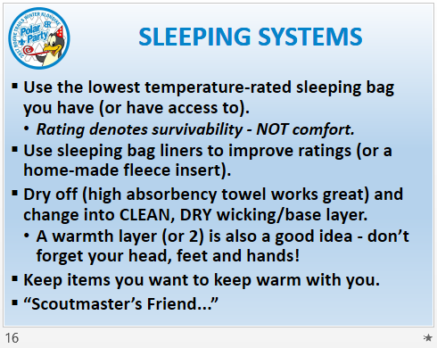 | - I can’t say enough about removing the clothes you wore during the day, DRYING OFF with a towel, and putting on CLEAN, DRY clothes to sleep in.  - You will be a bit chilly as you change clothes, but it’s temporary - trying to sleep in moist, damp clothes will make you cold ALL night!  - The “Scoutmaster’s Friend” is a plastic jug used as a “bedpan” for liquids.  - One of the things to keep warm (with you in sleeping bag) is a FULL water bottle to hydrate at night.
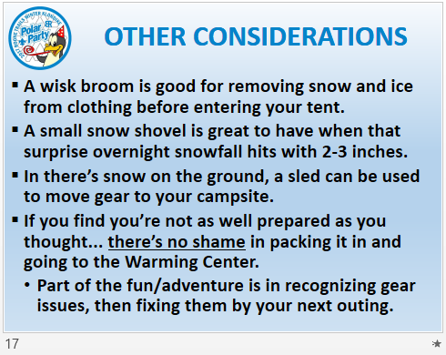 | Is it possible to get snow in the winter?  - Think about what’s possible and consider it in your planning.  - Think about what’s probable and include it in your planning.
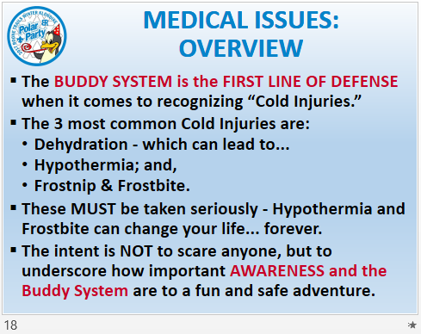 | - THE BUDDY SYSTEM... there it is again.  - Young men tend to “live in the moment” and don’t always think about the “effect” - just the “cause.” Adults need to be especially vigilant.  - ANALOGY: If there was a Copperhead curled up under your chair, wouldn’t you want me to tell you?!
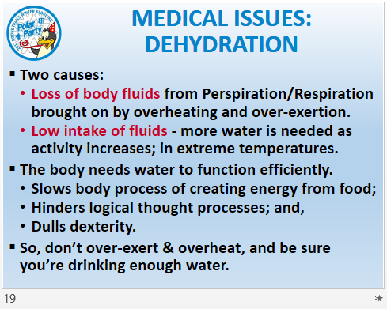 | - So basically, it’s a simple case of FLUIDS IN versus FLUIDS OUT.  - Just as “Comfortably Cool” was described as being a balance point, so too is proper hydration:  - finding a healthy balance between fluids out, and fluids in.
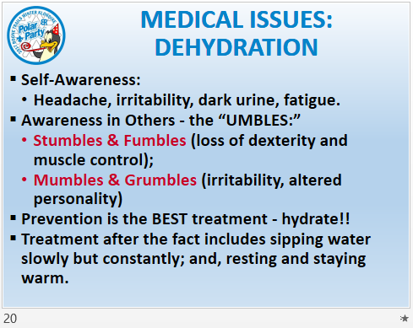 | - The “UMBLES” are great indicators: they’re easy to remember and they demonstrate a “hindered logical thought process” and “dulled dexterity.”  - And... “Awareness in Others” is the “Buddy System” once more.
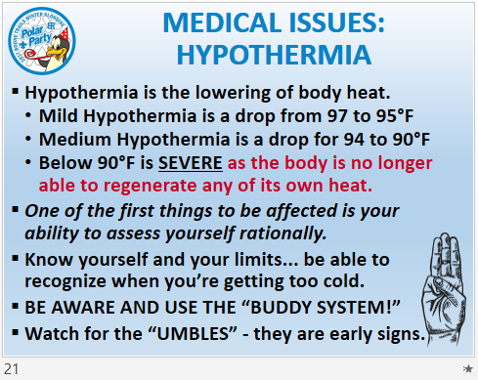 | - When the body can’t generate enough heat to keep up with the heat it is losing, staying warm becomes a downward spiral.  - What do you do if you think you’re hypothermic but you don’t trust your own judgement and rationality? [ANSWER: Ask someone else... the Buddy System!]  - Touching pinky to thumb, to make the Scout Sign, is a good Hypothermia test (it’s a simple test of manual dexterity).
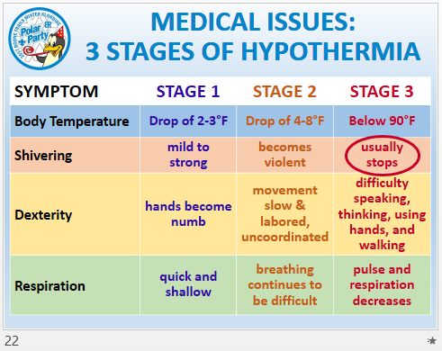 | - The body shivers to generate heat. When it stops, some people may even “think” they’re feeling better.  - They are not! This is a SERIOUS sign that things are critical.
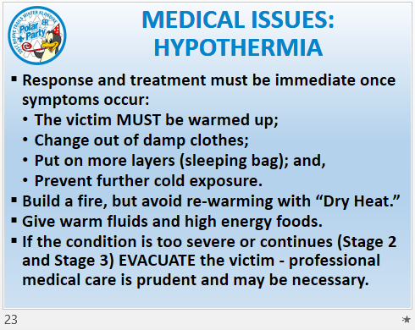 | - “DRY HEAT” includes heat sources such as open fires, wood stoves and hot-water bottles. Close or direct contact is too intense and harmful.  - The best way to warm a victim is skin-to-skin contact... something that has its own set of issues in Scouting. You have to make the best decision you can.  - Remember: Stage 2 and 3 Hypothermia, require professional medical help.
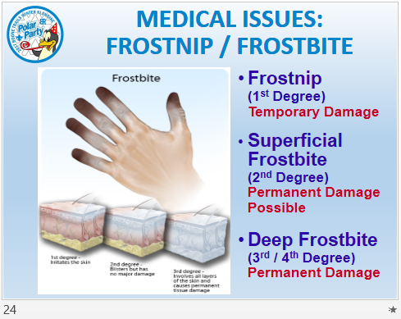 | - The classifications for frostbite follow those for burns with respect to Terminology and degrees.  - Frostnip (1st) - ice crystals form in Dermis, not totally frozen - temporary damage.  - Superficial (2nd) - Dermis frozen as well as parts of Epidermis.  - Deep 3rd - Dermis, Epidermis and parts of Subcutaneous frozen;  - Deep 4th - freezing of all upper layers, going into the muscle, nerves and bones.
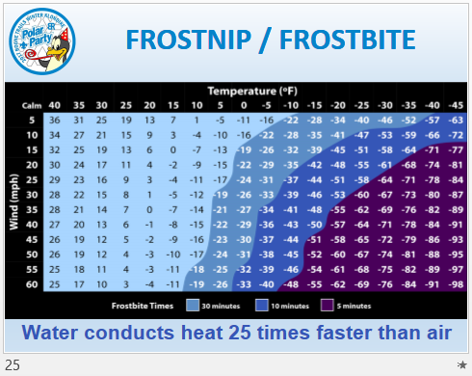 | - NOAA wind chill chart.  - Shows how cold it feels at given air temps and wind speeds.  - Medium Blue = takes about 30 minutes for exposed skin to be frost bitten.  - Darker Blue = takes 10 minutes  - Purple = takes only 5 minutes!  Can find via a Google Image search “NOAA Windchill Chart.”
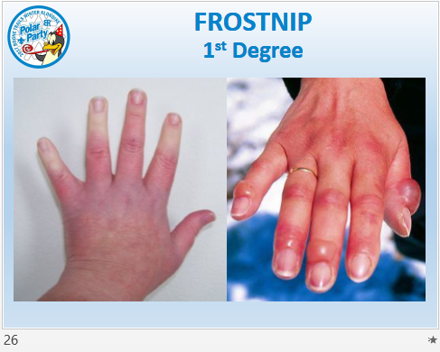 | - LEFT PICTURE: whitish area near ends of finger are Frostnip.  - RIGHT PICTURE: Thawed hand. Lots of red skin, Swelling and blisters from Edema (the seepage & collecting of tissue fluids from damaged cells).
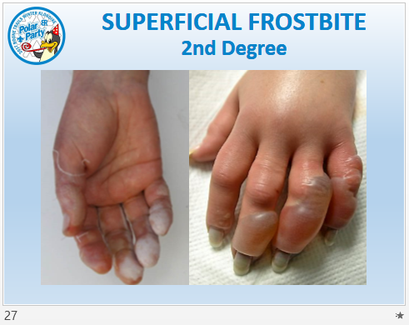 | - LEFT PICTURE: white coloration on fingertips clearly visible.  - Signs of desquamation (sheet-like peeling of the skin).  - RIGHT PICTURE: Edema more clearly visible - greater injury and damage to the cells means more fluid, which means bigger blisters and more swelling.  - Fingernails look dead (or close to it).
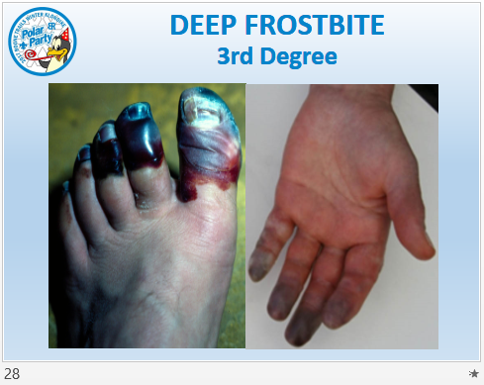 | - LEFT PICTURE: characteristic severe discoloration of toes; the remainder of foot has a slight bluish tint.  - RIGHT PICTURE: Discoloration of fingertips now purplish to charcoal, a clear sign of more severe frostbite.
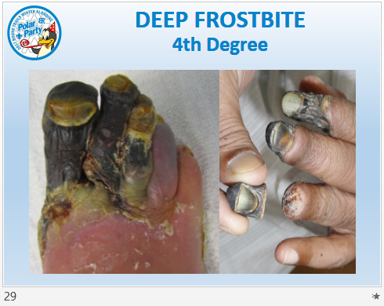 | - LEFT PICTURE: very severe discoloration; mummified skin; desquamation.  - Highly probable loss of 3 toes.  - RIGHT PICTURE: Auto-amputation of finger tip.  - Cold Injuries like this are pretty rare, especially in our climate, but ARE a very real possibility. Again, this isn’t to scare anyone... it’s just to raise awareness.
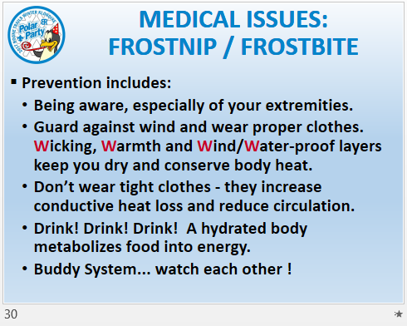 | - All pretty self-explanatory... our old friend the “Buddy System” is back...
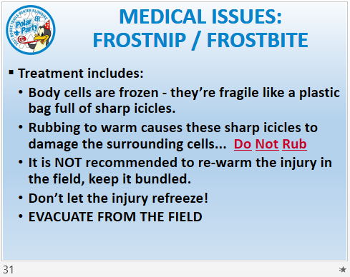 | - Rubbing Frostbite, especially with snow, is “Hollywood” and is NOT reality.  - DO NOT RUB a Frostbite injury!  - Two very critical parts: DO NOT LET THE INJURY REFREEZE, and EVACUATE THE VICTIM FROM THE FIELD (the victim needs immediate medical help).
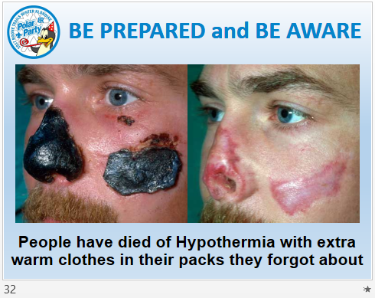 | - Frostbite can affect more than just hands and feet.  - ANY part of the body that protrudes out and away from the body is a target for Frostbite.  - This man obviously was scarred for life - but didn’t die from Frostbite injuries.  - The bottom comment stresses the importance of not just Being Prepared, but of CONSTANTLY Being Aware - of yourself, others, weather, surroundings...
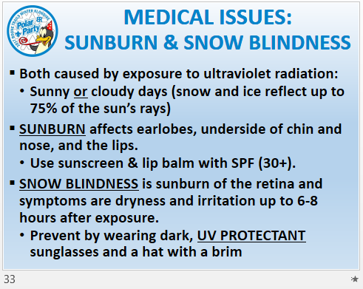 | - Dark sunglasses without UV protection make Snow Blindness worse:  - the darkness causes the pupil to dilate,  - this in turn provides greater access of the Retina at the back of the eye to the ultraviolet rays.
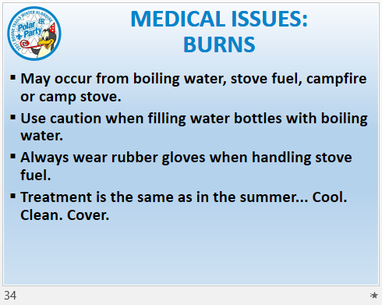 | - Burns are one of the most prevalent “ordinary” injuries when camping - winter or summer.  - Basic First Aid is based on a lot of common sense, regardless of the season.  - For example, do you lay someone on the cold ground in the recovery position, or do you put something down to insulate him from the cold ground first.
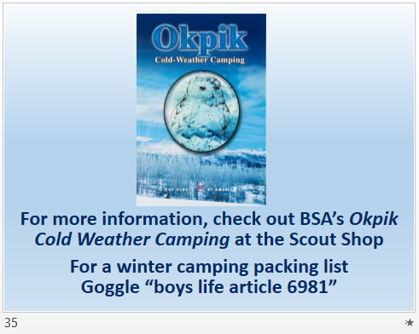 | - The majority of this information came from BSA’s book, “Okpik Cold Weather Camping.” It’s available at the Scout Shops and on Scoutstuff.org (Item #: 34040).  - “Winter Backpacking: Your Guide to Safe and Warm Winter Camping and Day Trips (Item #: 619127) by Ben Shillington is also available at most Scout Shops and on Scoutstuff.org  - For a winter camping packing list, Google “boys life article 6981”
BONUS INFORMATION
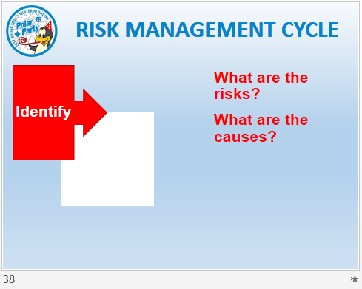  RISK | - What are the risks?  - What are the causes of those risks?
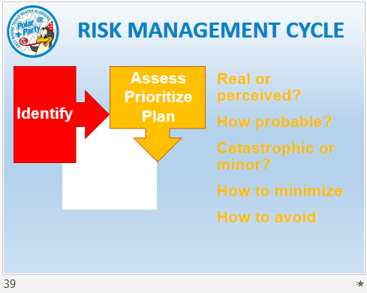  RISK | - Are the risks real or perceived?  - How probable (likely) are they?  - Is the risk potentially catastrophic, or minor?  - How can the risk be minimized/mitigated?  - How can the risk be avoided?
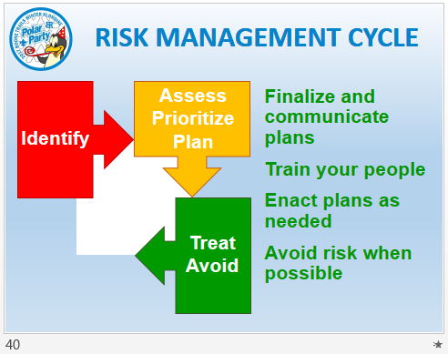  RISK | - Once all risks have been identified and evaluated, finalize and communicate your plans to deal with them.  - Train your people on what they need to do per the plans.  - Enact the plans as needed.  - Avoid risk whenever possible.  “NO UNECESSARY RISKS”
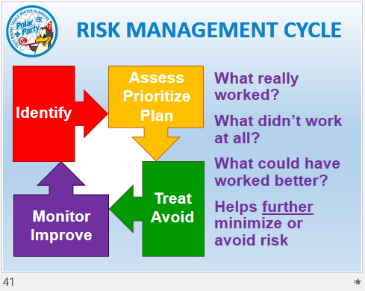  RISK | - Do an after-action evaluation (an NYLT SSC)...  - What really worked (and why)?  - What didn’t work at all (and why - for example, was it the plan or failure to train people?)  - What could have worked better (and how)?  - What’s learned via the after-action evaluation helps to further minimize or avoid risk.

