Tape Ball
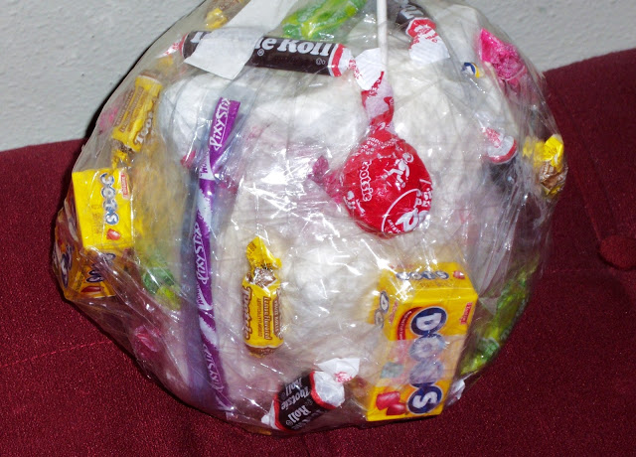
For pack meeting this month I need a little time to talk with the parents; which means I need an activity that will keep the boys interest as well as their siblings, but that my 14 year old will be capable of keeping control of. TAPE BALL to the rescue! They loved it!!! I forgot take my camera I wanted my daughter to take pictures of the boys playing, but they had a great time!! The only down side was that there wasn't enough time to get all the way though the ball, if I were to do it again I would make 2 or 3 smaller balls. (The remainder of the ball did not go to waste- enter a dad with a pocket knife! The rest of the goodies were retrieved while awards were presented.)
For those of you who have never heard of tape ball you take tape, I used masking and duct tape on the inside and clear packaging tape on the outside. It really is simple make a ball of tape with prizes taped inside, small toys and candy. (When we do this for holidays we put in money, giant pairs of underwear that sort of thing). Have everyone who is playing get in a big circle, one player gets the tape ball and the player in front of them a pair of dice. The player with the ball removes tape as fast as they can and anything they dislodge is theirs to keep. The player with the dice is trying to roll doubles as quickly as they can so they get a turn. As soon as they get doubles they pass the dice to the person next to them and then they get the tape ball.
Posted 23rd March 2012 by My husband calls me Noogie...?
Labels: games

