**Games for November 2015 Roundtable**

**Themes: A Scout is Reverent; Winter Wonderland**

**Game Title**: Guess the Object in the Picture

**Where Played:** Indoors or outdoors

**Type of Game**: The game emphasizes creative thinking outside the box.

**Number of Boys**: At least 2 teams of 3-4 boys. If more than 8 boys, divide into three teams or more but should have 3-4 boys in each team.

**Equipment Required**: Pictures of objects for each team; pen or pencil for each team

**Rules of the Game**:

1. The boys are divided into teams and are to determine a name for their group. They are then given a sheet of pictures labeled 1 through 16 in an envelope. They are to write the name of their group on the outside of the envelope.
2. Explain to the boys that, on your signal, they are take a sheet of pictures out of their envelope and try to determine what each object is in each picture. Some pictures will only have a part of the object, so they are to identify the object that the picture is a part of. They are to write the name of the object below each picture.
3. They will be given ten minutes to identify as many objects as possible.
4. When ten minutes are up, all groups will stop writing on their picture sheet
5. The leader will go through the pictures one by one, asking what each picture is. Each group will put a check mark on each picture they correctly identified and an X on each incorrect identification. There may be several correct answers for each picture,
6. The group with the most pictures correctly identified wins.

A sample sheet of pictures are given on the last page with a key. (Remove the key before giving the sheet to the boys or make your own picture page.)

**Game Title**: Winter Wonderland Word Search

**Where Played:** Indoors

**Type of Game**: Individual effort game

**Number of Boys**: Any number of boys can play

**Equipment Required**: Word search puzzle on a sheet of paper. One puzzle for each boy.

**Rules of the Game**:

1. Give each boy a word search puzzle sheet and a pen or pencil.
2. Each boy tries to find as many words or word phrases dealing with winter. This can also be done in teams with boys sharing answers. As each word or phrase is found, the boys should write it below the puzzle.
3. Although "snow” appears many time, there is only one time when it isn’t followed by another word, such as “snowman” or “snow angels”.

Macintosh HD:Users:Dalgor:Desktop:Word Search Generator // Make your own printable word searches @ A to Z Teacher Stuff - 19 words in the grid.pdf

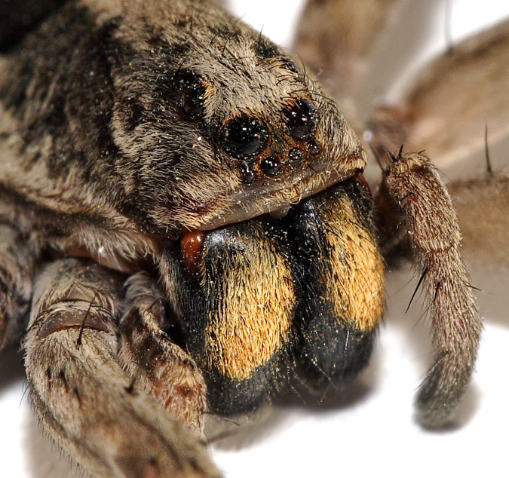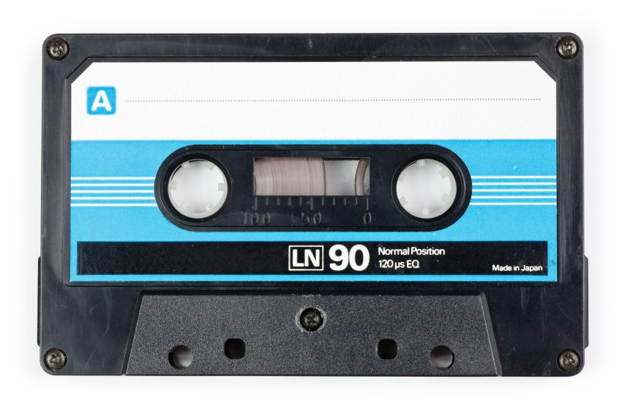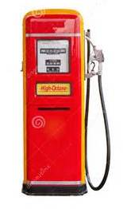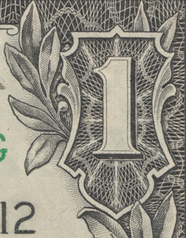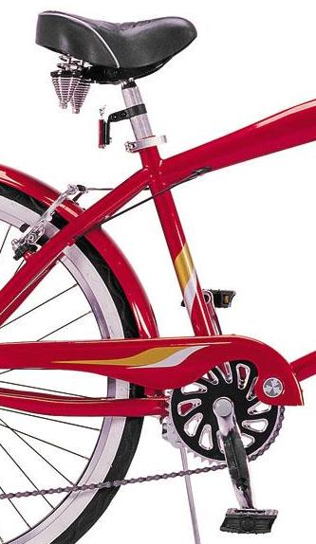

14

Key: 1. House key; 2. Gateway Arch; 3. Paper clips; 4. Green peas or peas; 5. Zebras; 6. Balloons; 7. Bicycle; 8. Dollar bill; 9. Spider; 10. Umpire; 11. Gasoline pump; 12. Hummingbird; 13. Cassette tape; 14. Tree; 15. Telephone; 16. Jack-o-lantern.

12

16

15

13

11

100

9

8

7

6

5

4

3

2

1