- Change has been a constant in Cub Scouting
  - Boy Lead, Den Leaders
  - Cub Scout Oath, Uniforms, Etc

- Current program analysis – Summary of Findings
  - Many advancement requirements support passive rather than active behavior
  - Leader aids are insufficient in guiding leaders on how to fulfill aims – lack tools and resources to implement aims
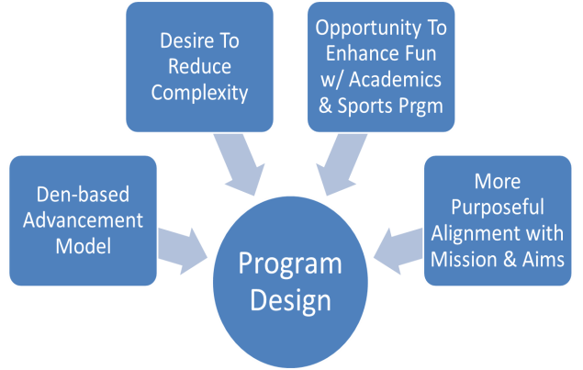
  - Youth handbooks lack breadth and frequency of activities / learning situations that support the aims
    - Character
      - Cub Scout program structure does not facilitate adequate coverage of all 12 Core Values
      - The youth handbook activities do little to facilitate the discussions necessary to leverage the methods and instill values
    - Citizenship: Current activities focus primarily in the area of civics/government with less emphasis on service and stewardship
    - Personal Fitness:
      - Rank advancement activities do not build foundation for life-long positive fitness habits
      - Our attention to nutrition within rank advancement is not proportionate to the need to address nutrition instruction and practices

- Desired Outcomes
  - Aims of Scouting (Character Development, Participatory Citizenship, Personal Fitness) + 2
  - Leadership & Life Skills; Outdoor Skills & Awareness
  - Adventures deal do not necessarily deal with only one outcome, but rather they weave together multiple outcomes to complete the activity
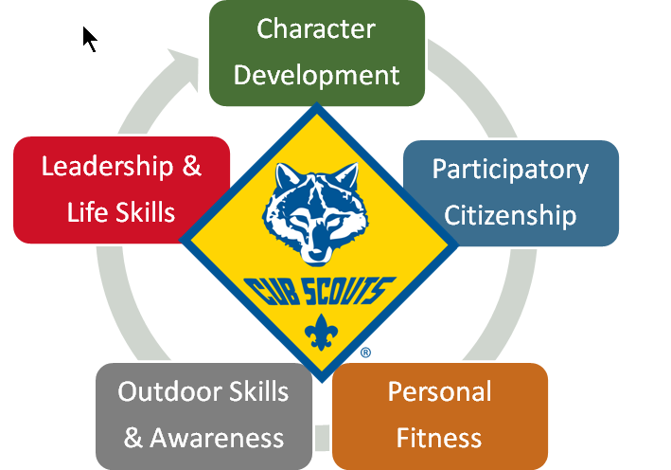
- New Program Basics
  - One Oath and Law
    - Move to Scout Oath and Law in all Programs
    - Age appropriate expectations

  - Bobcat Requirements
    - Learn and say the Scout Oath, with help if needed.
    - Learn and say the Scout Law, with help if needed.
    - Show the Cub Scout sign. Tell what it means.
    - Show the Cub Scout handshake. Tell what it means.
    - Say the Cub Scout motto. Tell what it means.
    - Show the Cub Scout salute. Tell what it means.
    - With your parent or guardian, complete the exercises in the pamphlet: How to Protect Your Children From Child Abuse: A Parent’s Guide – Bobcat Requirements

  - All ranks will complete: How to Protect Your Children From Child Abuse: A Parent’s Guide AND earn the Cyber Chip for their grade level
    - Official Statement: “If your family does not have Internet access at home AND you do not have ready Internet access at school or another public place or via a mobile device, the Cyber Chip portion of this requirement may be waived by your parent or adult partner.”

- Adventures
  - Theme based; Rigorous, but fun
  - Required and elective adventures
  - Den based, with opportunities for family involvement (Duty to God)
  - Each Adventure should take approximately 3 meetings, with one as an outing, where appropriate

- Seven Adventures required for Rank Advancement
  - Belt loops for Tiger, Wolf, Bear (6 defined / 1 elective)
  - Pins for Webelos and Arrow of Light (Webelos: 5 defined/ 2 elective; AOL 4/3)
    - More electives to prepare Scouts for freedom of choice in Boy Scouts

- Impact on Pack Budget = $71.59 per boy during the program
  - Adventure Loops: $1.39 each (3 years x 7 loops/yr - 9.73/year; 29.19 total)
  - Adventure Pins: $1.89 each (2 years x 7 pins/yr – 13.23/yr; 26.26 total)
  - Rank: $1.99 x 5 – 9.95
  - Webelos Colors: 1 @ 5.99

- What’s New? More Outdoors and more Boy Scout skills!
  - Camping introduced at Wolf level
    - Requirement adjusted for those boys who can’t camp. They need to attend but don’t have to stay overnight
  - Scouting Adventure (Arrow of Light requirement)
    - Requires troop visit in past.
    - Boys now attend meeting with a checklist to observe how the meeting is Boy Lead. Coordinate / Update your Troops of the new requirements
    - Boys will be well prepared for Tenderfoot
  - Arrow of Light
    - No longer Webelos 2 year; Now Arrow of Light Year
    - AOL can be earned without first earning Webelos Badge
      - Very helpful for boys who join the pack in 5th Grade
        - Den Leader doesn’t have to run two separate programs now
    - AOL was never cumulative (only Eagle Scout Rank is), it was meant to show the boy was ready to join Boy Scouts

- Immediate Recognition
  - Ensure that the boys are recognized immediately and publicly for their efforts
  - New loops and pins helps boys remember what they’ve done – not just a bead or arrow point

- Summary of Changes
  - Not Changing Changing
- Five of Cub Scout Methods - Ideals related
- Family focus - Oath & Law
- Ages (or genders) - Advancement related
- Bobcat still first rank earned - Tiger Cub becomes “Tiger”
- Ranks or approach - AOL no longer requires earning Webelos
- Den / pack meeting structure -Activities – more active, more aligned with Aims/Mission
- Outdoor program -Academics & Sports program retired
- Delivery model -Current immediate recognition devices replaced
-Fun – even more than before! -One Den Leader Guide per rank

- Timeline
  - Current program – active until May 21, 2015
  - New program – active on June 1, 2015

- Special Transition Situations
  - Boys earning their Webelos Badge prior to June 1, 2015
    - May continue to work out of the current handbook and complete the AOL requirements as stated OR
    - May convert to the new handbook and requirements
      - For electives – may utilize either the new adventure electives or electives earned under the current program but not used to fulfill Webelos rank requirements
    - Current pins and loops may be in limited supply towards Q4 2015 – consider planning ahead
  - Boys joining in the 5th Grade after May 31, 2015 (only applies for one year)
    - Must use the new program requirements and handbook
    - They may substitute any of the new program Webelos required adventures for the three required electives of Arrow of Light

- Cub Scout Changes: Implementation
  - New Youth Handbooks
    - More engaging, fully implement Aims of Scouting
    - Ethan – older scout guide
    - “Character Compass” – replaces Character Connection. References Scout Oath and engages Cubs in discussion
    - Akela Signature remains – parent, den leader, other adult involved. No change from current program
  - New Den Leader Materials – Print and Electronic E-reader copies
    - One Den Leader Guide per Level (Webelos / AOL combined)
      - Clear and Complete Meeting plans – no other references needed
      - Rationale – the why/what is to be accomplished
      - Takeaways – help the den leader visualize the scope of the adventure
      - Planning & Implementation Notes – upcoming events / materials that need to be arranged
  - Some activities have Home Assigments – don’t call it Homework
  - Den Planning
    - Coordinate your planning – adventures may involve other dens, or the pack as a whole. Work to plan your annual program
    - Consider the audience for the requirements – many adventures require the boys to demonstrate their new skills
  - Pack Meeting Planning
    - No change to pack meeting structure (Gathering time, opening, program, recognition, closing)
    - Monthly Themes will be based on 12 points of Scout Law
      - 2015-2016 &2016-2017 Pack Meeting Plans / Themes will be released by April 2015
        - Will be released on line – Scouting.org
      - 5 years will be developed
    - The new adventure program offers more opportunities for public speaking and interaction with others while at Pack meetings. It’s a Win-Win for the boys!
  - Annual Unit Program Planning
    - Pack program events can help support adventure requirements
    - Outdoor adventures, Pack campfires and Pack overnight camping
    - Use the Adventure Analysis worksheet to help plan your annual program

- Other Changes
  - Nova Awards / Super Nova Awards
    - Requirements being rewritten based on new adventures
    - Requirements to be released Q2 2015 with new books by June 2015
  - Shooting Sports
    - BB / Archery Loops going away
    - National committee considering new award / recognition
    - Will be announced in Fall 2015 at Camp School
  - Online Advancement System
    - Being revamped for new program
  - Adult Leadear Training
    - “What’s New” training module on E-Learning by end of March 2015
    - Updated Position specific training on E-Learning by end of March 2015
      - Minimal changes – if currently position trained, don’t have to retake
    - Minor updates to Outdoor training (BALOO, etc) to reflect new adventures

- Timeline
  - May 1st – Youth handbooks, Den Leader Guides, Cub Scout Leader Book
  - June 1st – New Program becomes active
  - June/July – new recognition devices available for purchase
    - Will not have to have an advancement report to purchase pins / loops

- Further Support
  - www.scouting.org/programupdates
  - Philmont Training Center – Summer 2015: Leading the Cub Scout Adventure

