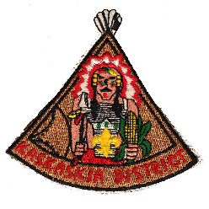SCOUT FAMILY OF THE YEAR
KASKASKIA DISTRICT
REQUREMENTS
The nominated family shall have been registered members for the entire year. The nominated adults shall have completed required training for their primary position(s). The nomination form shall list all registered members of the immediate family.
OTHER FACTORS FOR CONSIDERATION
______ Attends Roundtables _______ Active in District and/or Council
______ Years served as adult leader(s)
Single parent heads of family are eligible for the award, though multiple adult family members are typically nominated. Youth members are not required, but will be considered, if applicable.
All of the above requirements have been considered and I hereby nominate: NAMES (print, include adult position(s) and youth rank(s) if applicable)
ADDRESS ____________________________________________________ UNIT# ________ CITY/TOWN _________________________________________ PHONE ________________ Basis of nomination (include examples and advance training participated and/or staffed)

Other noteworthy service in their community: (Example – PTA, Church, Rotary)

***********************
NOMINATOR _____________________________________________ DATE ____________
PHONE _____________________ SCOUTING POSITION / UNIT________________/_____
2014 Revision If needed, use back of form or attach additional information
Greater St. Louis Area Council Boy Scouts of America

