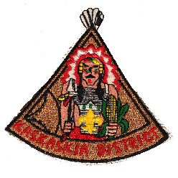
KASKASKIA DISTRICT
SCOUTER OF THE YEAR
REQUIREMENTS
The nominee shall have been a registered adult member of the BSA for the entire year. The nominee shall have completed required training for the primary position in which they serve at the time of nomination.
OTHER FACTORS FOR CONSIDERATION
______ Attends Roundtables _______ Active in District and/or Council
______ Has completed Wood Badge Training ______ Years served as a Leader
Awarded typically to those holding positions not otherwise eligible for position awards, such as Asst. Scoutmaster, Asst. Cubmaster, District Committee Member, etc.
All of the above requirements have been considered and I hereby nominate:
NAME (print) ______________________________________________ UNIT# ________ ADDRESS ___________________________________________________________________ CITY/TOWN _________________________________________ PHONE ________________ Basis of nomination (include examples and advance training participated and/or staffed)
Other noteworthy service in their community: (Example – PTA, Church, Rotary)
***********************
NOMINATOR _____________________________________________ DATE ____________
PHONE _____________________ SCOUTING POSITION / UNIT________________/_____

2013 Revision If needed, use back of form or attach additional information
Greater St. Louis Area Council Boy Scouts of America

