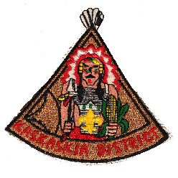
KASKASKIA DISTRICT
UNIT COMMITTEE MEMBER OF THE YEAR
REQUIREMENTS
The nominee shall have been a registered adult member of the BSA for the entire year. The nominee shall have completed required training for the primary position in which they serve at the time of nomination.
OTHER FACTORS FOR CONSIDERATION
______ Immediate impact on Unit
______ Unit achieved Gold / Silver / Bronze JTE Unit status (circle level) during year
______ Attends Roundtables _______ Active in District and/or Council
All of the above requirements have been considered and I hereby nominate:
NAME (print) _________________________________________________ UNIT# ________ ADDRESS ___________________________________________________________________ CITY/TOWN _________________________________________ PHONE ________________ Basis of nomination (include examples and advance training participated)
Other noteworthy service in their community: (Example – PTA, Church, Rotary)
***********************
NOMINATOR _____________________________________________ DATE ____________
PHONE _____________________ SCOUTING POSITION / UNIT________________/_____

2014 Revision If needed, use back of form or attach additional information

