6 District Spring
Camporee Guide
Shooting Sports/Mountain Man Adventure
May 1-3, 2020
Camp Lewallen in Silva, Mo

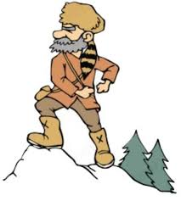
This Guide is provided to help Patrol Leaders and Scout Leaders prepare for the 6 district spring camporee!
Registration can be completed online at:
https://scoutingevent.com/312-6districtcamporee

We would like to thank Ameren Missouri for being an event sponsor!
SCHEDULE OF EVENTS
Subject to Change
Friday, April 27
4:00 PM Registration and check-in opens (Camp Office)
9:00 PM Registration closes
9:00 PM SPL and adult leader meeting (Dining Hall Flagpoles)
11:00 PM Taps (All quiet in camp)
Saturday, April 28
6:00 AM Reveille
8:00 AM Finish breakfast
9:00 AM Morning colors/Patrol competition begins (dining hall flag poles)
12:00 PM Lunch
1:30 PM Patrol competition resumes
4:30 PM Afternoon ends
5:00 PM Evening colors (dining hall flag poles)
7:00 PM Protestant/Scouts Own Service (Chapel)
8:00 PM Campfire (Lake Amphitheater)
11:00 PM Taps (All quiet in camp)
Sunday, April 29
6:00 AM Reveille
11:00 AM Units should be departed (Please leave your camping area cleaner than you found it)
Please Note that Units are responsible for providing their own meals for Breakfast, Lunch and Dinner.
INTRODUCTION / OVERVIEW
The camporee allows scouts to participate in one of the oldest traditions in the history of Scouting, an opportunity to match skills against others. There is fun, friendship, and competitions. The theme of this year’s Camporee is…. “Shooting Sports/Mountain Man Adventure”.
This Guidebook provides details on events and logistics that unit leadership needs to know to ensure a fantastic experience for their scouts.
Each event is hosted and scored by volunteers (adult leaders of each unit). Additional events could be added that may not be listed in this Guide should a higher unit turnout occur. These games will not be announced ahead of time in orderto ensure suspense on what may or may not occur. Be Prepared for unexpected changes!
Registration information is available is online through the black pug website and the link can be found at the beginning of this guide. The cost is $10 per person for adults and scouts until April 16th then rises to $12 per person. The registration fee covers the cost of camping, an exciting patch, prizes, awards, insurance and program/game materials.

Check-In
Units begin check-in from 4:00 to 9:00 p.m. on Friday evening at the Camp Office.
NOTE: Please limit the amount of vehicles beyond the 2nd gate. Utilize the parking lots as much as possible to cut down on vehicle traffic within camp.
There will be an SPL/Leaders meeting on Friday night at 9:00 p.m. Please have at least one youth and adult present at that meeting. At that time, the SPL will receive unitevent cards for each patrol for Saturday’s event competitions and will be told critical information for the weekend’s events. If additional staffing is required units may be asked to provide volunteers.
There will be also Cracker Barrel and movie in the dining for all attendees starting at 9:00 p.m.
NOTE: All Scouts and Adult Leaders are asked to bring their own cups, mugs, Nalgene’s, etc. to the Cracker Barrel and for use during the weekend.
Scheduling Note
All competition events are held on Saturday concluding with awards given at the Campfire. All units check out Sunday morning and please remember to leave your campsite cleaner than you found it.
Camporee Staff
The Camporee staff is completely volunteer. They donate a great deal of time and effort to make this a successful event and are ready to answer any questions or provide service.
Rules of Conduct
The Scout Law, Scout Oath and Outdoor Code are the guiding rules for all Camporee activities. All participants, both Scouts and Adults, are expected to follow the Oath and Law at all times. All events, with the exception of the Dutch Oven Cook-off should be done as a Patrol, except for adult leaders that participate in activities exclusive to them.
Safety
There are a number of shooting sports activities that are a part of the competition. When patrols get to these stations, they need to have permission to enter into the various shooting sports areas. It is also recommended to bring eye and ear protection when the Scouts are around the shotgun and rifle ranges. Going over rules while on a range would be very beneficial for all Scouts at a troop meeting before the camporee occurs.
Criteria for Success When Participating in any Event
➢ Spirit, teamwork and participation
➢ Patrol yell and flag
➢ Troop number and flag clearly posted in the campsite
Patrol Competition Cards
Each patrol will be issued a competition card at the Friday night meeting. This card must be turned into the Camp Office on Saturday Afternoon after patrols complete all of the stations. This card will also be rejected if not turned in by 5:00 p.m. Winners for each event are announced at the Saturday night campfire. Each patrol should participate in as many events as possible to maximize chances of. Smaller troops may combine their Scouts if needed to form a patrol.
Campfire Performance and Entertainment
One highlight of Scouting is having skits, songs and similar performances at the campfire. There is a youth Campmaster who will be running the campfire on Saturday night.
Campfire
The campfire will take place starting promptly at 8:00 PM Saturday night. All Scouts and Adult Leaders are asked to be at the flagpoles in front of dining hall by 7:40 p.m. The campfire activity includes issuance of ribbons and awards, skits and performances. After the Campfire everyone returns to their campsite. Lights out is at 11:00 PM.
Dutch Oven Cook-Off
There is one special event scheduled for Saturday afternoon. This will be a Mountain Man theme Dutch Oven Cook-off for both youth and adults. There will be a two categories, one for Dutch Oven Main Dish and one for Dutch Oven Desserts. These should satisfy hungry mountain men who generally survive off of the land and eat whatever they can find or grow. You must provide your own supplies (charcoal and starter fluid) and all ingredients. Cook in your campsite or Camporee Headquarters (Valley Lodge). All entrees must be brought to the Climbing Tower Pavilion for judging between 4:00 and 4:30 p.m. Saturday afternoon. Prizes will be awarded based on “taste” that is most appealing to hungry youth and adult judges. Youth and adult entrees will be judged separately for both main dish and desert. There will be a prizes for the Dutch Oven Cook-Off winners.
Event Scoring
At each of the competitions, Patrols will be scored based on skill, time to completion, and teamwork. Different scoring criteria exist for each event. Participation also plays a significant role in the total score as another variable in the calculation.
To ensure all patrols have an opportunity to win an event, and that not all awards go to patrols with older youths with more experience in Camporee activities there are two divisions, older and younger. Based on information provided on the patrol competition card, depending on the average age of all patrol members, awards will be issued for both divisions. Scout spirit is judged at each event! Be sure to have your patrol flag and BE PREPARED to give your patrol yell when both beginning the event and before leaving “without” being asked to give it.

Patrol Events
- Shotgun Shooting (Shooting Sports Range)- Patrols choose up to two of their members to shoot. Scoring will be based on how many clay targets get shot by the patrols.
- Rifle Shooting (Shooting Sports Range)- Patrols choose up to 5 members to shoot. Scoring will be based on the grouping of the shots fired.
- Archery (Shooting Sports Range)- Patrols choose up to 5 members to shoot. Scoring will be based on the score from shooting the arrows.
- Tomahawk Throwing (Spring Hollow)- Patrols choose up to 5 members to throw. Scoring will be based on the score from throwing tomahawks.
- Fire Making (Voyageur Area)- Patrols will be timed on how long it takes them to build a fire that successful burns through twine that will be a certain height off of the ground.
- Pioneering (Pine Forest)- Patrols will be timed on how long it takes them to build a tripod and suspend a weather rock in between.
- First Aid (Trees between Dining Hall and Office)- Patrols will have a timed mock scenario of having to render first aid due to some type of injury then carry the victim on a stretcher for certain distance.
- Throwing object (Spring Hollow Pavilion)- This event is still being planned out but the Scouts will have to throw or toss an object as far as they can. The object will be revealed when the Scouts are at the station.

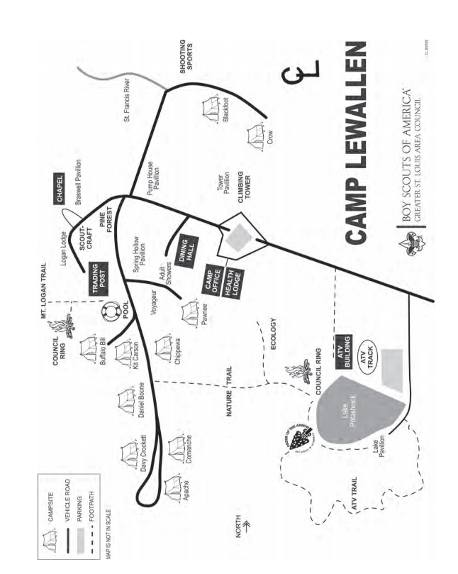
Archery
Shotgun Shooting
Rifle Shooting
Firemaking
Pioneering
First Aid
Tomahawks
Object Throwing

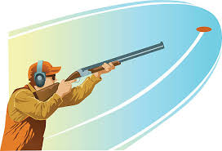
Registration Form
Six District Spring Camporee
May 1-3 2020

Register online or in person
https://scoutingevent.com/312-6districtcamporee
Cost is $10 per Scout/Scouter. Fee increases to $12 after April 16.
Unit # _______
Adult Contact: _____________________ Cell Phone #:_________________________
Adult Contact Email: ____________________________
Troop SPL at Camporee: _________________________
Number of Competing Patrols: ____________________
Total # of Scouts: ____________ Total # of Adults: ____________

Make 1 check payable to GSLAC
BSA Ritter Service Center
3000 Gordonville Road
Cape Girardeau, MO 63703

Or
Southern Illinois Service Center
803 East Herrin St.
Herrin, IL 62948
Income Account Code (1.6801.26.20)

