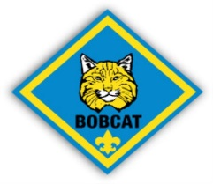
Thunderbird District Bobcat Roundup
October 6, 2018
Cub World at Beaumont Scout Reservation
Come join us as we celebrate the start of your Scouting Experience.
We will have tons of fun at the Cub World play area.
Cost is free. Bring a friend, bring your whole family.
Tours of all that Beaumont offers, with plenty of time to play.
Campsites, Old West Fort, Pirate Ship, Eagle Tower
Boy Scouts from the District will teach your Cubs all of the
Bobcat Requirements.
The Thunderbird Training Staff will provide
Youth Protection Training at 9:00am
Den Leader/Cub Master Training starting at 11:00am
Come and get your training while your Cubs are having the time of their lives.
Cost for Cub Leader Training will be to cover materials only.

