Boys Scouts of America | Greater St. Louis Area Council
Rock Climbing & Rappelling
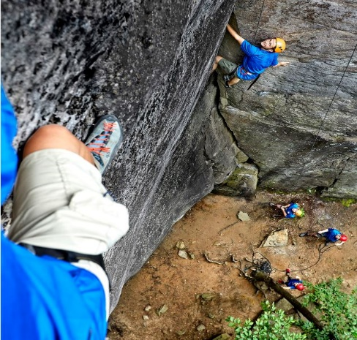

Rock Climbing & Rappelling Training – Signing Up

When making your reservation, you must inform the Camping Department what Service Center training you will be attending. If no one indicates that they will attend the Wednesday meeting at a Service Center no one from the Rock Climbing Staff will be at that location for training.
If you can’t make the Wednesday night meeting you will still be able to take the weekend training but you must call the Climbing Training Course Director. On Wednesday night everyone will receive knot training, a detailed equipment list, and training about equipment and what to bring for weekend training and the Saturday camp at the climbing area.

FAQs
Age: You must be at least 21 years old to take training.
Fitness: The training is very active and high energy. There is no sitting around and it is all outdoors, rain or shine. Don’t sign up thinking this will be lectures or classroom work!

Instructor Training 2019
Register and Pay on-line at the training section on the Council website: http://bsaarchive.webtestdev.com/training/adult/rock-climbing
General Information
The Wednesday night and weekend training course is required to become a Qualified Rock Climbing/Rappelling Instructor for the Greater St. Louis Area Council sites. You will receive site specific training for the natural climbing areas at S Bar F Ranch and Camp Vandeventer, Giant City Illinois State Park (near Pine Ridge Scout Camp in Southern Illinois) and at Pere Marquette Illinois State Park (gear is stored at Camp Warren Levis in Godfrey, IL); and for the climbing towers at Beaumont and Camp Lewallen. Climbing training at either camp qualifies you to take your unit climbing at all of our council’s climbing program sites.
S bar F Scout Ranch and Camp Vandeventer are Greater St. Louis Area Council camps and both have great natural rock climbing sites. These sites have permanent anchors installed for climbing and rappelling. The anchors and procedures are identical at both camps.

Training Schedule and Information – Spring and Summer

May 22 (evening) + June 1-2 (weekend) at S Bar F Scout Ranch, Knob Lick MO
Wednesday May 22 at 7:00pm at the Emerson Center at Beaumont Scout Reservation or the Belleville Service Center.
Saturday, June 1, meet at the parking lot of Castle Rock at S bar F at approximately 7:30 AM. We will hike out of the parking lot at 8:00 AM sharp – don’t be late; we leave at 8:00 with or without you.
Sunday June 2, we will finish training about 4:00 PM

August 14 (evening) + August 24-25 (weekend) at Camp Vandeventer, Waterloo IL
August 14, 2019 at 7:00 PM at the Emerson Center at Beaumont Scout Reservation, or the Belleville Service Center.
Saturday August 24, meet at the parking lot near the dining hall at approximately 7:45 AM. We will hike out of the parking lot at 8:00 AM sharp – don’t be late; we leave at 8:00 with or without you.
Sunday August 25, we will finish training about 4:00 PM

FEES: Initial weekend training: $25 – includes bandana, notebook, and two patches.
If you have taken Challenge Course Training, bring your notebook, only $5.

BE PREPARED for a great outdoor training experience so that your Scouts can have a super Challenge Course experience!

